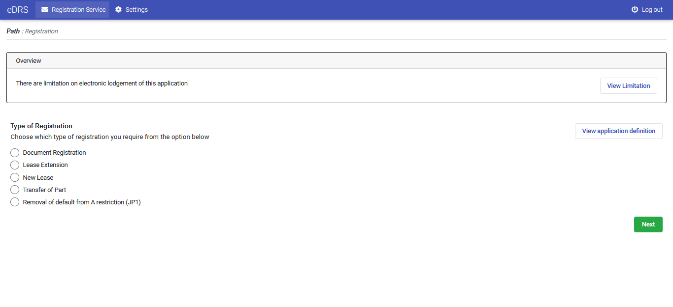

Figure Registration Services

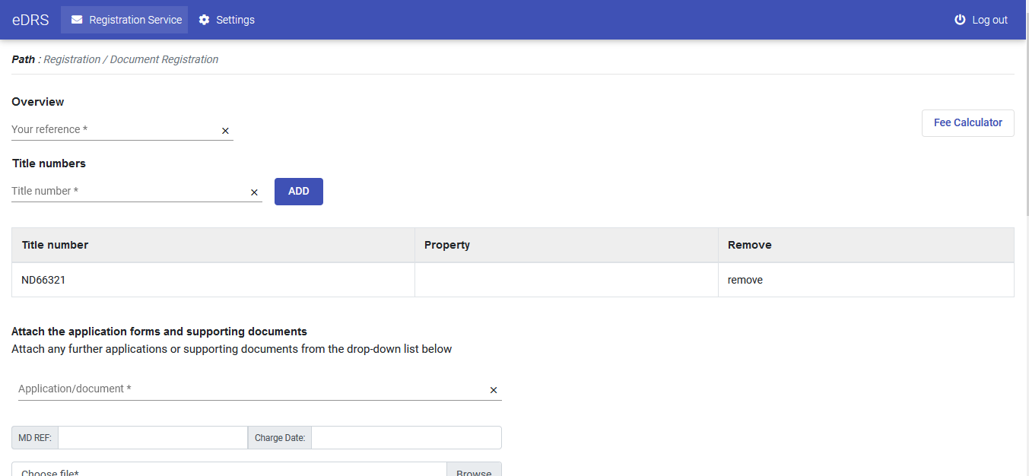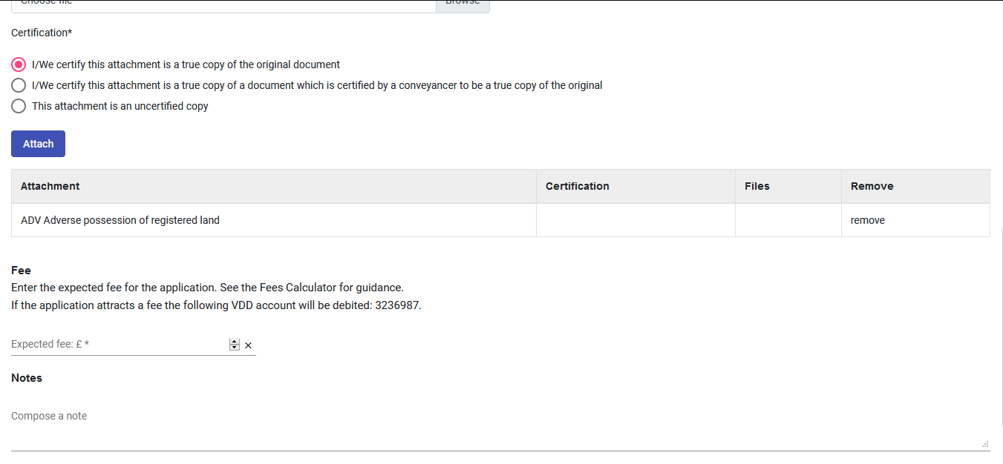

Figure Document Registration

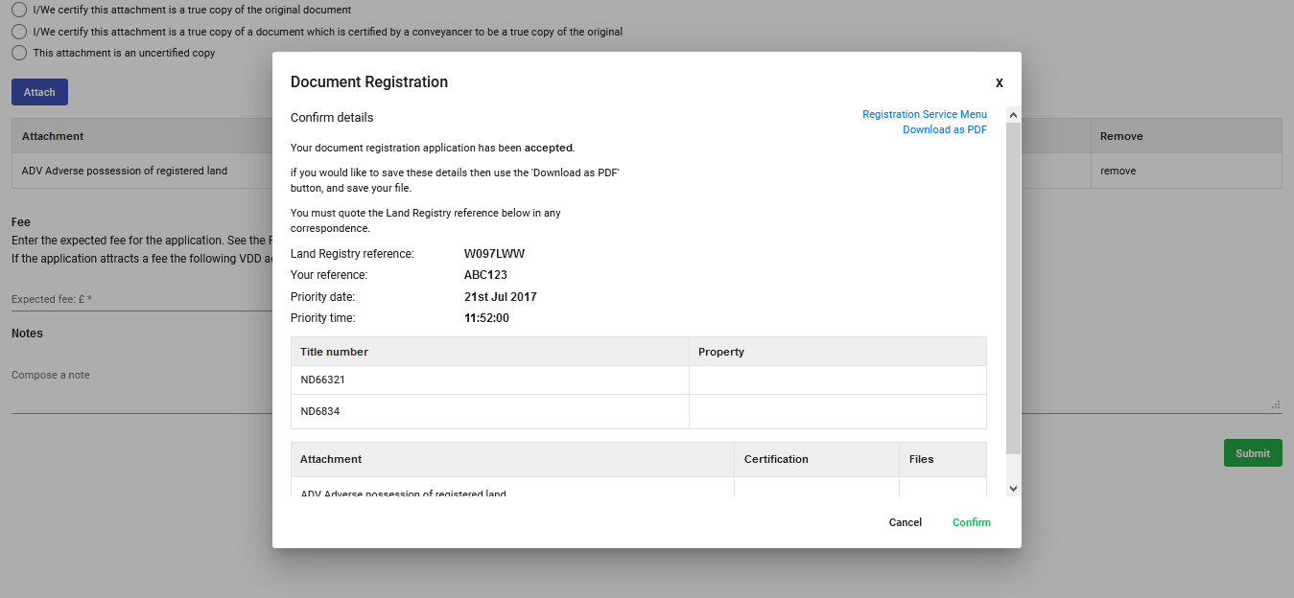

Figure Document Registration Confirmation

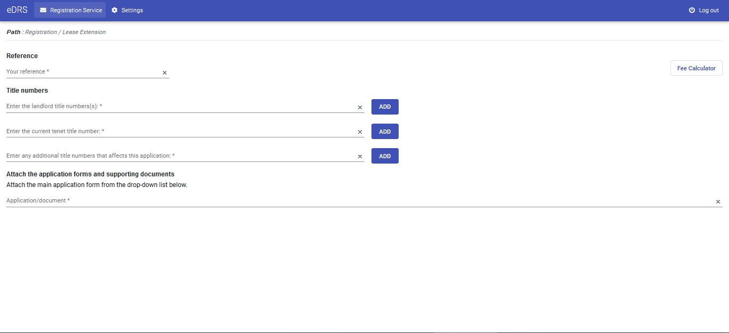

Figure lease Extension

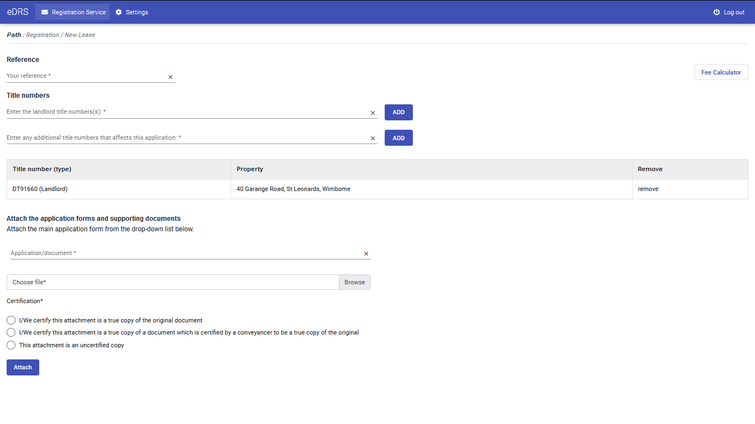

Figure New Lease

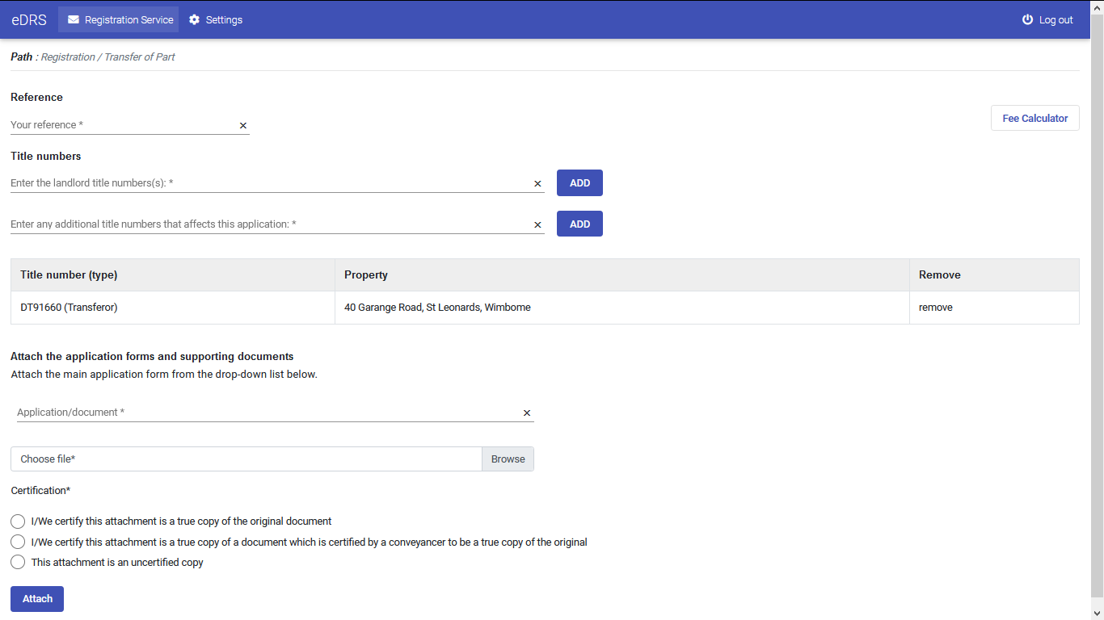

Figure Transfer of Part

I didn’t create a screen for Removal of default from A restriction(JP1) since we can reuse the Document Registration form with some minor changes.